House Training Your Puppy
Copy wright 1999, Denver Dumb Friends League. All rights reserved.
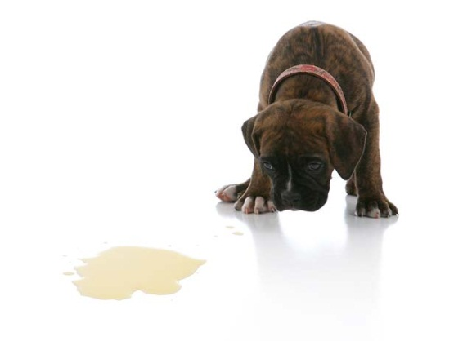
House training a puppy requires time, vigilance, patience, and commitment. Following the procedures outlined below, you can minimize house soiling incidents, but virtually every puppy will have an accident in the house (more than likely several). Expect this to be part of raising your puppy. The more consistent you are in following the basic house training procedures ,the faster your puppy will learn acceptable behavior. It might take several weeks to house train your puppy, and with some of the smaller breeds, a bit longer

Establish a Routine
- Like babies, puppies do best on a regular schedule. Take you puppy outside frequently, at least every two hours, and immediately after he wakes up from a nap, after playing, and after eating.
- Praise your puppy lavishly every time he eliminates outdoors. You can even give him a treat. You must praise him and give him a treat immediately after he is finished. Not after he comes back inside the house. This step is vital, because rewarding your dog for eliminating outdoors is the only way he will know what you expect from him.
- Choose a location not too far from the door to be the “potty “spot. Always take your puppy on a leash directly to the bathroom spot. The smell will help your puppy recognize the area as the place he is supposed to eliminate. While your puppy is eliminating, use or phrase like “go potty”. This could be used eventually before he eliminates to remind him of what he is supposed to be doing.
- If possible, put your puppy on a regular feeding schedule. Depending on their age, puppies usually need to be fed three to four times a day. Feeding your puppy at the same time each day will make it more likely that he will eliminate at a consistent time. This makes house training easier for both of you.

Supervise
Don’t give your puppy an opportunity to soil in the house. He should be watched at all times when he is indoors. You can tether him to you with a six foot leash, or use baby gates to keep him in the room where you are. Watch for signs like, sniffing around or circling. When you see these signs, immediately take him outside on a leash to his “potty spot”. Praise him lavishly and reward with a treat.
Confinement
When you are unable to watch your puppy at all times, he should be confined to a small area. Enough that he won’t want to eliminate there. It should be just big enough for him to comfortably stand, lie down, and turn around. This area could be a portion of a bathroom or laundry room. Crate training can be very useful in a variety of situations. If your puppy has spent several hours in confinement, when you let him out, take him directly to his bathroom spot. Praise him when he eliminates.
Oops!
Expect your puppy to have an accident in the house. It is a normal part of house training a puppy.
- When you catch him in the act of eliminating in the house, do something to interrupt him, like make a startling noise (be careful not to scare him). Immediately take him to his bathroom spot, praise him and give him a treat if he finishes eliminating there.
- Don’t punish your puppy for eliminating in the house. If you find a soiled spot, it’s too late to administer a correction. Do nothing but clean up. Rubbing your puppy’s nose it, taking him to the spot and scolding him, or any other punishment or discipline will only make him afraid of you or afraid to eliminate in your presence. Punishment will do more harm than good.
- Cleaning the soiled area is very important because puppies are highly motivated to continue soiling in areas that smell like their “potty spot”.
- It’s extremely important that you use the supervision and confinement procedures outlined above to minimize the number of accidents. If you allow your puppy to eliminate which will prolong the house training process.

Paper Training
A puppy under six months of age cannot be expected to control his bladder for more than a few hours at a time. If you have to be away from home for more than four or five hours a day, this may not be the best time for you to get a puppy. If you’re already committed to having a puppy and have to be away from home for long periods of time, you might have to train your puppy to eliminate in a specific place indoors. Teaching your puppy to eliminate on new paper may create a lifelong surface preference, meaning that he may even in adulthood eliminate on any newspaper he finds lying around the house.

Other types of House Soiling Problems
If you’ve consistently followed the house training procedures and your puppy continues to eliminate in the house, there may be another reason for his behavior.
- Medical problems: House soiling can often be caused by physical problems such as a urinary tract infection or a parasite infection. Call our office to rule out any of these possibilities.
- Submissive / Excitement urination: some dogs, especially young ones temporarily lose control of their bladders when they become excited or feel threatened. This usually occurs during greetings, Intense play, or when they are about to be punished.
- Territorial Urine marking: Dogs sometimes deposit urine or feces in small amounts to scent /mark their territory. Both male and female dogs do this, and it is most often when they believe their territory has been invaded.
- Separation anxiety: Dogs that become anxious when they are left alone might soil in the house as a result. Usually, there are other symptoms, such as destructive behavior or vocalization.
- Fears or Phobias: when animals become frightened, they may lose control of their bladder and or bowels. If your puppy is afraid of loud noises, such as thunderstorms or fireworks, he might soil the house.

