How to Brush Your Dog’s Teeth
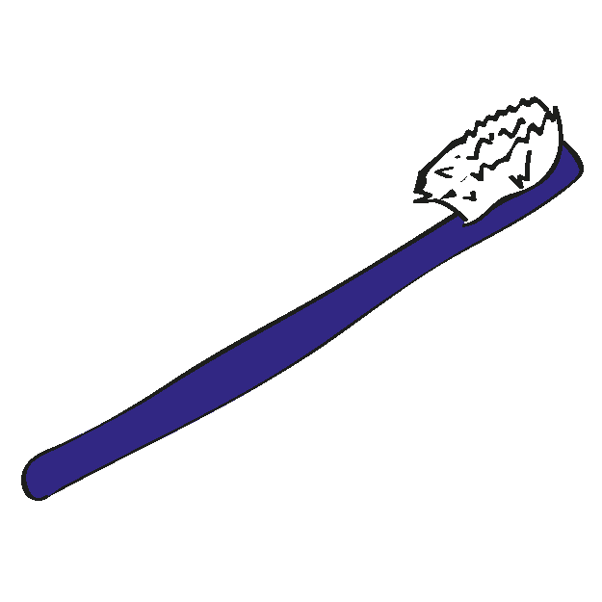
Puppies start losing their “baby teeth” between four and six months of age. The front teeth, called incisors, will be lost first. The new, permanent teeth will push out the “baby” teeth. When your puppy begins to lose his teeth, he may have foul breath and you may notice blood on any hard items he may chew on.
Even though most adults brush their teeth morning and night they still have their teeth cleaned once or twice a year by a dental technician. Dogs are no different than humans as far as proper dental care is concerned. When a dog eats a meal, food accumulates where the teeth meet the gums. Bacteria in the mouth eat the food deposits and the result is plaque. Plaque causes inflammation at the gum line called gingivitis and eventually a pocket forms between the gum and the root of the tooth. The soft plaque eventually becomes a very hard deposit on the teeth called “calculus”. As the calculus accumulates on the teeth and the gingivitis progresses, the pocket between the tooth root and the gum line becomes deeper. As a result, the attachment holding the root of the tooth to the gum is destroyed. The gum recedes exposing the tooth root. Eventually, the bone holding the tooth in place is destroyed and the tooth falls out or must be extracted.
Brushing your puppy’s teeth between the ages of eight and sixteen weeks is critical and it will make the job easier when he is an adult. Buy toothpaste formulated for dogs. It’s flavored so dogs love the taste. Start with a little dab of toothpaste on your finger and let your puppy taste it. Then slip your finger under his lip and rub the toothpaste on his teeth. When you are finished, let your puppy have a food treat.
- This is very important. Do not use regular human-formulated toothpaste for your dog. Most toothpaste includes fluoride, which is EXTREMELY poisonous to dogs.
- Try to choose a time when your pet has had a decent amount of exercise, so they are more inclined to sit quietly during the procedure.
- Handle your pet’s muzzle and touch their lips. Work up to rubbing the teeth and gums with your finger. Use a small amount of pet specific toothpaste. This is flavored for pets to enjoy.
- Introduce a soft veterinary or human toothbrush to brush the teeth. Hold the brush at a 45-degree angle to the tooth and brush gently back and forth or in a circular pattern from gum to tip. Brushing the tongue side of the teeth is less critical, but still good. Offer rewards and treats when your pet allows you to brush.
- Don’t overdo it the first few times. Start slowly, and stop the procedure if your pet gets agitated – even if you have not yet brushed the whole mouth.
- You can increase the time every day as he/she gets used to the procedure. Also, make sure to speak soothingly and pleasantly during the brushing. Before too long, your pet should begin to look forward to this experience.
- Pick rubber chew toys that will help keep the teeth clean. Avoid natural bones, which are hard enough to fracture teeth.

Virbac C.E.T. Enzymatic Dog & Cat Malt/Seafood/Poultry Flavor Toothpaste
C.E.T. Toothpaste is specially formulated to be safe, effective, and appealing to your dog or cat. The toothpaste contains the C.E.T. Dual-Enzyme System to inhibit the formation of plaque. It is formulated specifically for dogs and cats - they contain no foaming agents, and are meant to be swallowed. The flavors are well accepted by pets, and make brushing easy!

Key Benefits:
- Suitable for both dogs and cats
- Great tasting flavor your pet will love
- Acts quickly to help eliminate mouth odors
- Enhanced Dual-Enzyme System provides effective and natural antiseptic action

